Ansible Task 2

- Install httpd using ansible playbook, use handlers, notifiers.
- Write a ansible playbook to install apache tomcat.
- Write a ansible playbook to provision one ec2 on aws.
- Write a ansible playbook to copy one file from node-1 to node-2.
- Write a ansible playbook to create different files with different names using single playbook.

Exercise 1: Install Apache using a playbook with handlers and notifiers
A handler runs only when a task notifies it. In this example, Ansible installs Apache, copies a custom web page, and restarts Apache when the page changes.
Execution flow
Ansible playbook
Install Apache and copy web page
Task changes → notify: Restart Apache
Handler restarts Apache

Step 1: Create the playbook
On your Ansible master:
cd ~/ansible-lab
nano install-apache.yml
Paste this complete playbook for your Ubuntu workers:

---
- name: Install Apache with handler and notifier
hosts: workers
become: true

tasks:
- name: Install Apache
ansible.builtin.apt:
name: apache2
state: present
update_cache: true

- name: Copy custom web page
ansible.builtin.copy:
content: |
<html>
<body>
<h1>Apache deployed using Ansible</h1>
</body>
</html>
dest: /var/www/html/index.html
owner: root
group: root
mode: "0644"
notify: Restart Apache

- name: Ensure Apache is enabled and running
ansible.builtin.service:
name: apache2
state: started
enabled: true

handlers:
- name: Restart Apache
ansible.builtin.service:
name: apache2
state: restarted

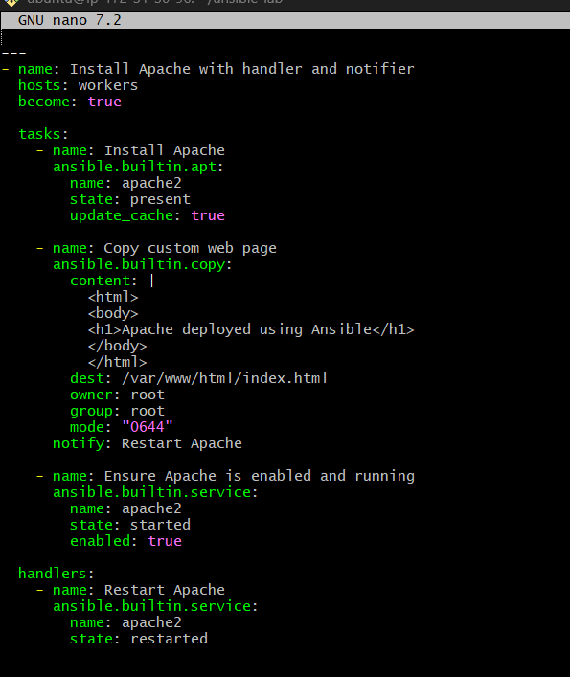
Save and exit: Ctrl+O, Enter, Ctrl+X.

Step 2: Execute
ansible-playbook -i inventory.ini install-apache.yml

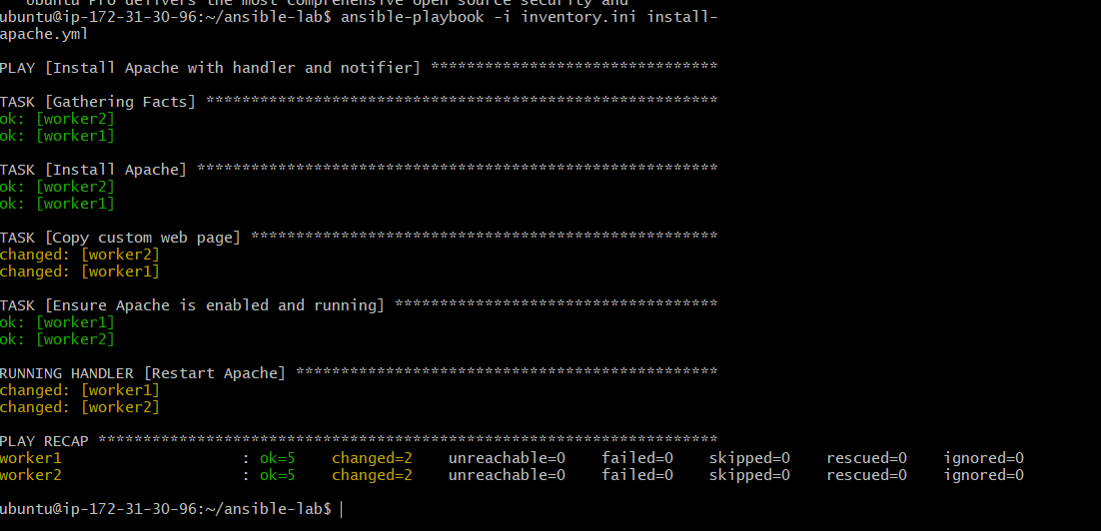

Step 3: Verify
ansible all -b -m shell -a "systemctl is-active apache2 && curl -s http://localhost" -i inventory.ini
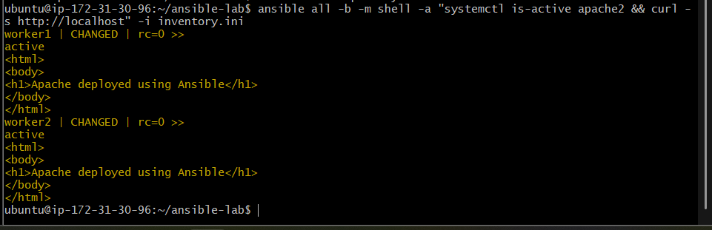
Expected: active and the HTML containing Apache deployed using Ansible.
For Amazon Linux, the package and service are usually httpd, and the package module is dnf on Amazon Linux 2023. Do not use the Ubuntu version unchanged on Amazon Linux.

Exercise 2: Install Apache Tomcat using a playbook
We'll use the Ubuntu package manager to install Java and Tomcat 10 on your existing workers.

Step 1: Create the playbook
nano install-tomcat.yml
Paste:

---
- name: Install and start Apache Tomcat
hosts: workers
become: true

tasks:
- name: Install Java and Tomcat
ansible.builtin.apt:
name:
- default-jdk
- tomcat10
state: present
update_cache: true

- name: Enable and start Tomcat
ansible.builtin.service:
name: tomcat10
state: started
enabled: true

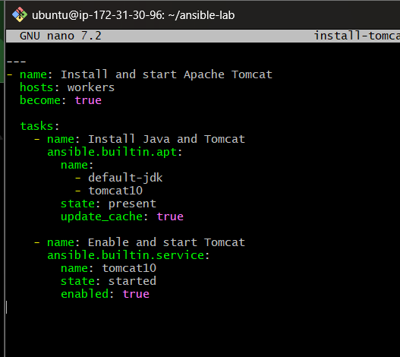

Step 2: Run the playbook
ansible-playbook -i inventory.ini install-tomcat.yml
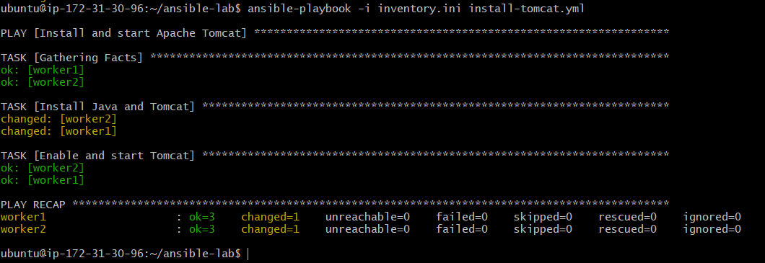

Step 3: Verify
ansible all -b -m shell -a "systemctl is-active tomcat10" -i inventory.ini
Expected output: active on both workers.
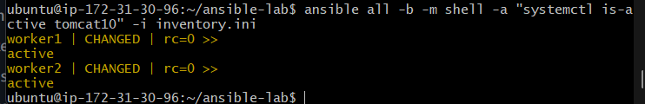
Check the default Tomcat port locally:
ansible all -b -m shell -a "ss -lntp | grep ':8080'" -i inventory.ini
Tomcat commonly listens on port 8080. If the Ubuntu repository doesn't provide tomcat10 or the service name differs, check the package and service names before proceeding.
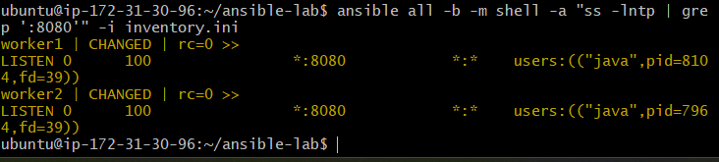

Exercise 3: Provision one EC2 instance on AWS using Ansible
This playbook creates one new EC2 instance using the amazon.aws collection. Unlike the first two exercises, this task creates a billable AWS resource.

Step 1: Prepare the AWS requirements
On your Ansible master, verify that your AWS credentials work:
aws sts get-caller-identity
Install the collection:
ansible-galaxy collection install amazon.aws
The Python AWS SDK is also needed:
sudo apt update
sudo apt install -y python3-boto3
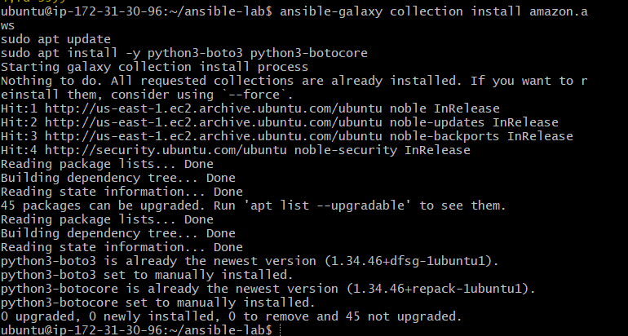

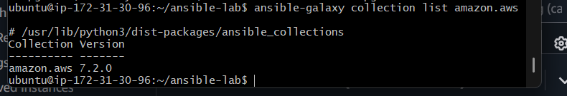
Before running the playbook, you need these AWS values:
- AWS region
- An existing subnet ID
- A security group ID that permits SSH from your IP
- An existing EC2 key pair name
- An AMI ID valid for that region
Use your own values; don't guess the AMI or subnet.

Step 2: Create the playbook
nano create-ec2.yml
Paste this complete playbook and replace the placeholder values:

---
- name: Provision one EC2 instance
hosts: localhost
connection: local
gather_facts: false

vars:
aws_region: us-east-1
ami_id: ami-REPLACE_WITH_VALID_AMI_ID
subnet_id: subnet-REPLACE_WITH_SUBNET_ID
security_group_id: sg-REPLACE_WITH_SECURITY_GROUP_ID
key_name: REPLACE_WITH_EXISTING_KEY_PAIR
instance_type: t3.small

tasks:
- name: Launch one EC2 instance
amazon.aws.ec2_instance:
name: ansible-created-instance
region: "{{ aws_region }}"
image_id: "{{ ami_id }}"
instance_type: "{{ instance_type }}"
key_name: "{{ key_name }}"
vpc_subnet_id: "{{ subnet_id }}"
security_groups:
- "{{ security_group_id }}"
network:
assign_public_ip: true
count: 1
state: running
wait: true
register: ec2_result

- name: Display instance details
ansible.builtin.debug:
var: ec2_result.instances

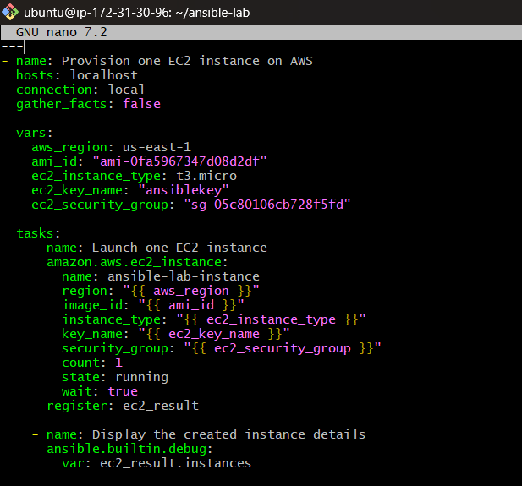

Step 3: Run it
ansible-playbook create-ec2.yml
The playbook runs on the master, uses your AWS credentials, and requests one running instance.
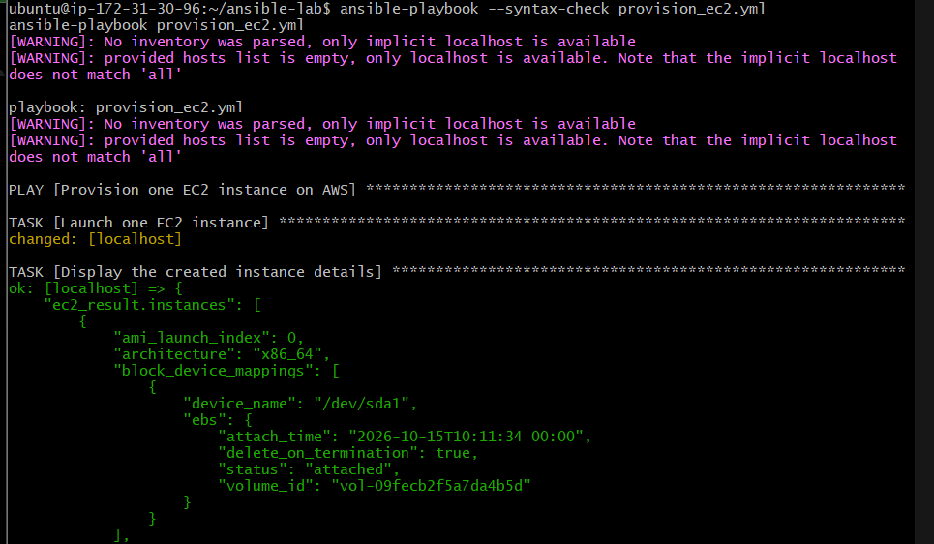
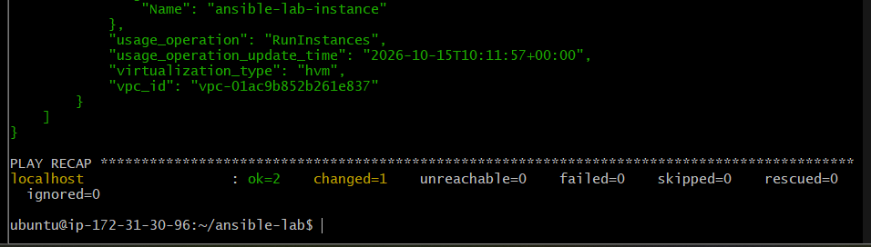

Step 4: Verify in AWS
Check the EC2 console in the selected region, or use the AWS CLI:
aws ec2 describe-instances \
--region us-east-1 \
--filters "Name=tag:Name,Values=ansible-created-instance" \
--query 'Reservations[].Instances[].[InstanceId,State.Name,InstanceType]' \
--output table

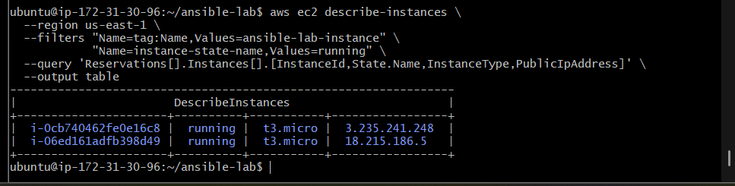

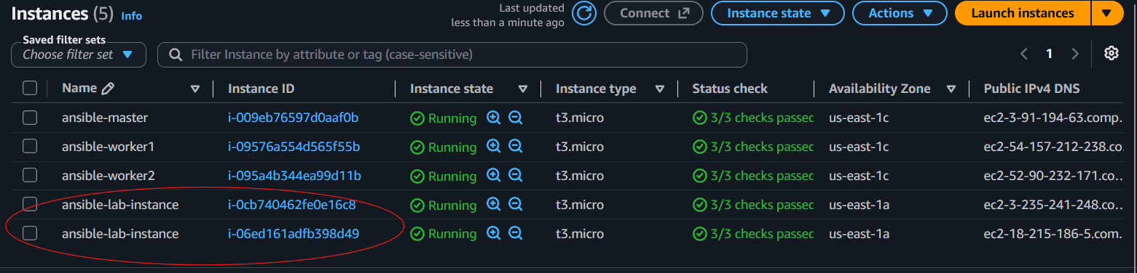

Exercise 4: Copy a file from node-1 to node-2
Ansible normally runs tasks through the control node. To transfer a file between workers, we can first fetch the file from worker1 to the master, then copy it from the master to worker2.
Assume:
- Source node: worker1
- Destination node: worker2
- Source file: /tmp/share.txt

Step 1: Create a source file on Worker 1
Run this on your Ansible master:
ansible worker1 -i inventory.ini -b -m copy \
-a "content='File copied from Worker 1 to Worker 2 using Ansible\n' dest=/tmp/task4-file.txt owner=ubuntu group=ubuntu mode=0644"
Verify that the file exists:
ansible worker1 -i inventory.ini -b -m command \
-a "cat /tmp/task4-file.txt"
Expected output:
File copied from Worker 1 to Worker 2 using Ansible
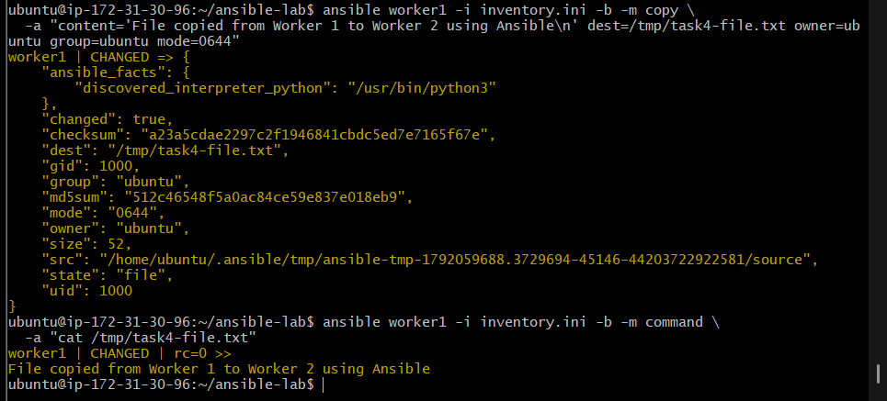

Step 2: Create the playbook
On the master:
nano task4_copy_file.yml
Paste this complete playbook:

- name: Copy a file from Worker 1 to Worker 2
hosts: workers
gather_facts: false
tasks:
  - name: Fetch file from Worker 1 to the Ansible master
ansible.builtin.fetch:
src: /tmp/task4-file.txt
dest: /tmp/task4-transfer/
flat: true
when: inventory_hostname == "worker1"
  - name: Copy file from the Ansible master to Worker 2
ansible.builtin.copy:
src: /tmp/task4-transfer/task4-file.txt
dest: /tmp/task4-file.txt
owner: ubuntu
group: ubuntu
mode: "0644"
when: inventory_hostname == "worker2"
Save with Ctrl+O, press Enter, and exit with Ctrl+X.
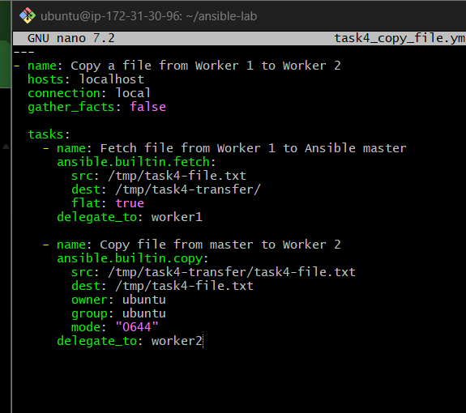

Step 3: Run the playbook
ansible-playbook -i inventory.ini --syntax-check task4_copy_file.yml
If the syntax check succeeds, run:
ansible-playbook -i inventory.ini task4_copy_file.yml
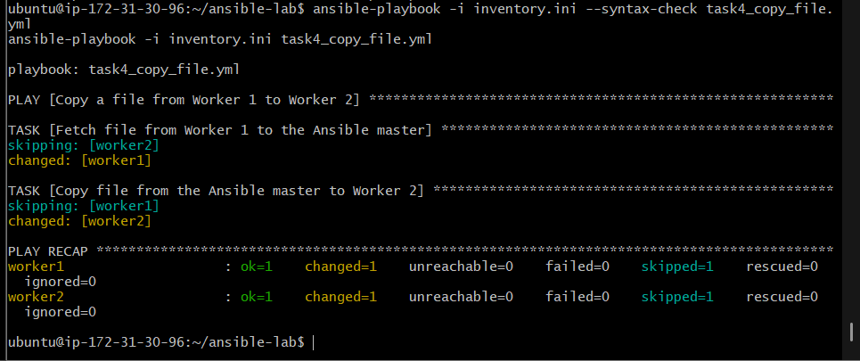

Step 4: Verify the destination file
ansible worker2 -i inventory.ini -b -m command \
-a "cat /tmp/task4-file.txt"
Expected output:
File copied from Worker 1 to Worker 2 using Ansible
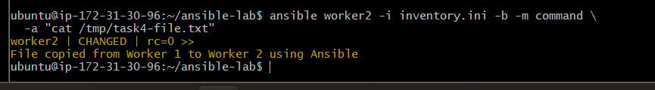
You can also verify the file's permissions and ownership:
ansible worker2 -i inventory.ini -b -m command \
-a "ls -l /tmp/task4-file.txt"
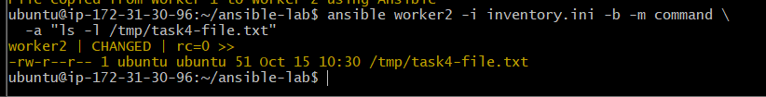

Exercise 5: Create multiple files with different names using one playbook
Objective: Create several files with different names on both Worker 1 and Worker 2 using a single playbook.

Step 1: Create the playbook
On your Ansible master (172.31.30.96), run:
cd ~/ansible-lab
nano task5_create_files.yml
Paste this complete playbook:

- name: Create multiple files on worker nodes
hosts: workers
become: yes
gather_facts: false
tasks:
  - name: Create files with different names
ansible.builtin.file:
path: "/tmp/{{ item }}"
state: touch
owner: ubuntu
group: ubuntu
mode: "0644"
loop:
    - file1.txt
    - file2.txt
    - devops.txt
    - ansible.txt
    - task5.txt
Save with Ctrl+O, press Enter, then exit using Ctrl+X.
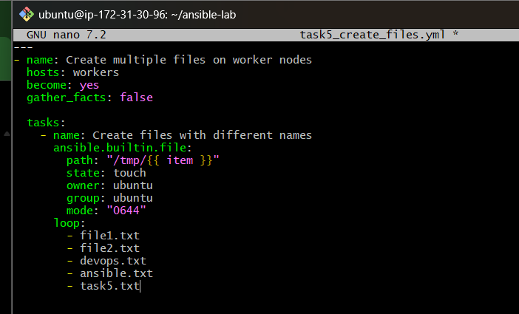

Step 2: Check the playbook syntax
ansible-playbook -i inventory.ini --syntax-check task5_create_files.yml
Expected output:
playbook: task5_create_files.yml

Step 3: Execute the playbook
ansible-playbook -i inventory.ini task5_create_files.yml
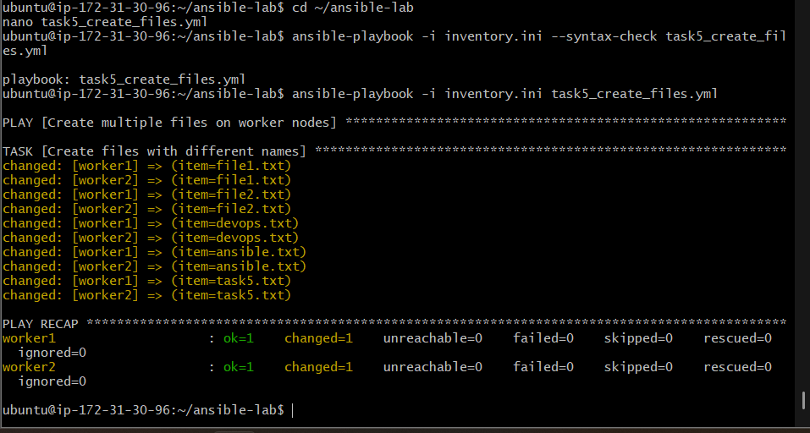
The loop runs the file-creation task five times on each worker.

Step 4: Verify the files
Check Worker 1:
ansible worker1 -i inventory.ini -b -m command \
-a "ls -l /tmp/file1.txt /tmp/file2.txt /tmp/devops.txt /tmp/ansible.txt /tmp/task5.txt"
Check Worker 2:
ansible worker2 -i inventory.ini -b -m command \
-a "ls -l /tmp/file1.txt /tmp/file2.txt /tmp/devops.txt /tmp/ansible.txt /tmp/task5.txt"
You should see all five files on both workers, owned by ubuntu:ubuntu, with permissions 0644.
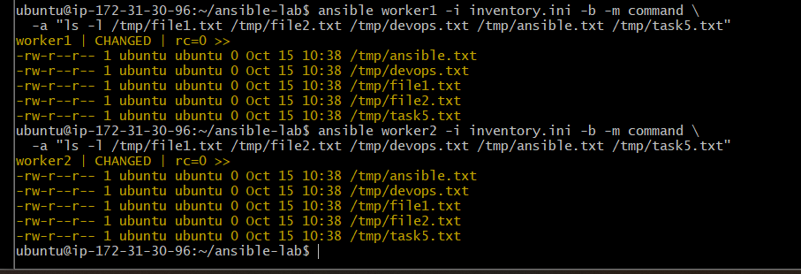

How it works
- hosts: workers — runs on both Worker 1 and Worker 2.
- become: yes — uses elevated privileges to manage files.
- ansible.builtin.file — creates or manages files.
- state: touch — creates a file if it doesn't exist; otherwise updates its timestamp.
- loop — repeats the task for each filename.
Expected result: 5 files on Worker 1 + 5 files on Worker 2 = 10 file instances created or managed by one playbook.

